OneList Plus

Overview

Contents
MESSAGING 2
QUICK PITCH 2
TOP-LINE BENEFITS 2
SUPPORTING STATISTICS 2
DETAILED BENEFITS 3
FEATURES 4
FEATURES OVERVIEW ………………………………………4, 5, 6
CUSTOMER EXPERIENCE 7
SALES SUPPORT 12
PROBING QUESTIONS 12
SELLING POINTS 12
OBJECTION HANDLERS 13
FREQUENTLY ASKED QUESTIONS 15
GENERAL 15
LISTING AND BUSINESS INFORMATION 16
DIRECTORY SPECIFIC QUESTIONS 18
LISTING SUBMISSION 19
REPORTING 19
CONTRACT/CANCELLATION 20
FULL DIRECTORY LIST 21
TOP DIRECTORIES 21

Messaging

Quick Pitch
Get businesses listed and help them get found online with OneList Plus.
The new customer journey begins with online searches, and it is essential for businesses to get found where customers are searching.
OneList Plus helps improve local SEO. Business are listed with important information across the top online maps, business directories, social platforms and GPS systems using one simple dashboard. Having a business listed with consistent information helps with local SEO and boosts visibility when potential customers are searching online.
Users submit or update business information once, and the directory listings will automatically be created and updated in up to 40 directories. The platform locks the listings and performs daily monitoring scans to ensure the information is accurate and consistent.
Users can drive more traffic to their website, get more calls from interested customers, and grow sales for the business.

Top-line Benefits
- Help businesses get found online: Automated online presence management publishes business information across all relevant directories, search engines and social networks. Not only will having the business listed in multiple directories help search engines like Google verify the business information as correct, it will also boost SEO by creating links to the website. Plus, customers searching within local directories themselves are more likely to find the business.
- Save time: No more manual updates, creating separate profiles in every directory and losing track of profiles and log-ins. OneList Plus submits and updates the listings simultaneously. Updates are submitted in one place and pushed across all listings.
- Reach more customers: Customers who research online, purchase offline. With OneList Plus, users are improving their chances of getting found when and where customers are searching.
- Cost effective: OneList Plus is a small investment that can help businesses get in front of customers at the right time.

Supporting Statistics
- People use local directories to find local businesses. 97% of users searched online to find a local business. (Safari Digital 2023)
- Businesses need to focus on their local search results. 98% of consumers used the internet to find a local business in the last year, with 21% searching every day (BrightLocal 2023).
- It’s important the directory listings are correct and up to date. Approximately 86% of people search for a location of a business on Google Maps, making it critical for brands to have updated online listings on Google. (99 Firms 2022) 64% of consumers have used Google Business Profile to find contact details for local businesses (BrightLocal 2023).

Detailed Benefits

One-time submission for up to 9-40+ directories | - Instead of creating and managing the business listings across different online directories and keeping track of links and log-in information, OneList Plus lets users submit their business information in one place.  - Next time users need to update their business information, their address, or phone number, they only need to update it once in their OneList Plus dashboard and the information will be synced across all directories supported.
Consistent “NAP” and contact information | - Search engines like Google improve results by checking information from all over the web. It is especially important the “NAP” or name, address, phone number is consistent in spelling and formatting across the web to help improve SEO or search engine ranking.  - It is important that information about businesses on third-party sites and directories is accurate so search engines including Google can confirm business details and so customers or potential customers always get accurate business contact information when they are searching online.
Improve business visibility and local SEO | - Automated online presence management publishes user’s business information across all applicable directories and search engines.  - Listing the business details and website in well-established third- party sites and directories helps create more backlinks to the website to aid with SEO. Citations, even without listing a domain, can also help with SEO to build a business’ credibility with search engines.  - Customers searching for local businesses on directories can find the user’s business.
Enhance listings with rich data | - OneList Plus lets users add keywords, descriptions, business category, logo, images of their business, links to their social profiles and more to enhance their directory listings. Rich data will be published in any directories that support additional details about the business.
Inexpensive advertising | - Online directories are an inexpensive method to increase visibility with potential customers.
Save time and money | - Save advertising budget with online presence for local search in Google and other search engines.  - No more manual updates. OneList Plus updates all listings simultaneously. Whenever users have an update, we’ll make sure it gets published on all applicable directories.
Targeted advertising | - Users get in front of consumers looking for their products and services. When consumers are using a business directory, they are looking to meet a specific and immediate need. Users can make sure their business is showing up when customers are looking.

Features
Directory listings | - OneList Plus syncs with major online directories, rating and review sites, navigation systems, apps and social networks. The directories included depends on the plan.  - OneList Plus will also suppress any duplicate listings, which will help with SEO and ensure accuracy of business information within search engines.  - Once listed, OneList Plus locks listing where applicable so third parties are not able to change the information.  - Note: With Google Business Profile and Facebook®, users will need to allow OneList Plus to sync with their new or existing profiles by connecting them within their OneList Plus dashboard.
Add all relevant  business information from one place | - List key business information including name, address and phone number in important local directories and map platforms.  - Users can also submit added information about their business to boost their online credibility and search results:  - Business category  - Website  - Email, fax and mobile phone  - Open hours  - Keywords and business descriptions  - Logo and images of the business  - Add extra details to optimize the listings and provide customers with all the information they are looking for:  - Services offered  - Payment options  - Languages users serve customers in  - Brands users sell or support  - Video links  - Plus, add social account links.  - Note: The information published per directory will depend on the fields each directory supports.
Photos added to directories | - Certain directories will display a logo and images of the business or services as part of the business listing. Upload and manage images through the OneList Plus dashboard.  - Upload a cover image for Google, Facebook® and other applicable directories for a professional finish to the listing.
Ongoing directory syncing | - OneList Plus scans the listings daily to ensure the business information stays up to date.  - Upon submission, existing listings, merged and/or duplicate directory listings are removed for consistency.
Dashboard and monthly reporting | - View profile completeness, missing details on the listings, listings submitted and listings needing connection.  - View the OneList Plus dashboard to view monthly insight reporting and Profile impressions, including clicks on certain directories (Google Business Profile & Facebook®) if applicable.

DIY OneList Plus Plans (Maps & Directory Management)

Features | OneList Plus 13 | OneList Plus 25 | OneList Plus International | OneList Plus 40
Number of Directories | 13 | 25 | 25 | 40+
Available Countries | Canada & US | Canada | 10+ | US
Near Real-time directory submissions & updates via API | ✓ | ✓ | ✓ | ✓
Protect & Lock Listings | ✓ | ✓ | ✓ | ✓
Duplicate Suppression | ✓ | ✓ | ✓ | ✓
Customer Dashboard Access | ✓ | ✓ | ✓ | ✓
Reputation & Reviews Monitoring (on applicable directories) | No | No | No | No
Reputation Management & Reviews Response (on applicable directories) | No | No | No | No
Automated Reviews Notification (on applicable directories) | No | No | No | No
Location Analytics & Insights Dashboard | ✓ | ✓ | ✓ | ✓
Google Business Profile | ✓ | ✓ | ✓ | ✓
Google Maps | ✓ | ✓ | ✓ | ✓
Facebook | ✓ | ✓ | ✓ | ✓
Bing Maps* | ✓ | ✓ | ✓ | ✓
Navmii | ✓ | ✓ | ✓ | ✓
Opendi* | ✓ | ✓ | ✓ | ✓
HERE (maps) | ✓ | ✓ | ✓ | ✓
whereto | ✓ | ✓ | ✓ | ✓
Brownbook | ✓ | ✓ | ✓ | ✓
Hotfrog | ✓ | ✓ |  | ✓
Waze | ✓ | ✓ | ✓ | ✓
Show Me Local | ✓ | ✓ |  | ✓
Foursquare |  | ✓ |  | ✓
Yalwa* |  | ✓ | ✓ | ✓
Acompio.com |  | ✓ |  | ✓
Pages24.com* |  |  |  | ✓
iglobal* |  | ✓ |  | ✓
info-us.com (infobel) * |  | ✓ |  | ✓
Tupalo |  | ✓ |  | ✓
Car manufacturer |  | ✓ |  | ✓
Uber |  | ✓ | ✓ | ✓
Cylex* |  | ✓ | ✓ | ✓
Yelp |  | ✓ |  | ✓
Instagram |  | ✓ | ✓ | ✓

Baidu Intl |  | ✓ |  | ✓
Apple Maps |  | ✓ | ✓ | ✓
Yandex |  |  | ✓ | ✓
Mylocalservices.com |  |  |  | ✓
Citysquares |  |  |  | ✓
Localstack |  |  |  | ✓
Manta |  | ✓ |  | ✓
Judy’s Book |  |  |  | ✓
UScity.net |  |  |  | ✓
n49.com / n49.ca |  | ✓ |  | ✓
Chamber of Commerce |  |  |  | ✓
EZLocal |  |  |  | ✓
YaSabe |  |  |  | ✓
Houston Chronicle |  |  |  | ✓
Univision |  |  |  | ✓
LA Voz |  |  |  | ✓
Palm Beach Post |  |  |  | ✓
Mundo Hispanico (AJC) |  |  |  | ✓
Statesman (The Austin American Statesman) |  |  |  | ✓

Customer Experience
Users will receive a Welcome email containing their log-in credentials. Users Log into their main dashboard and select Advanced Tools > Applications > OneList Plus to get started. This will launch the OneList Plus dashboard.
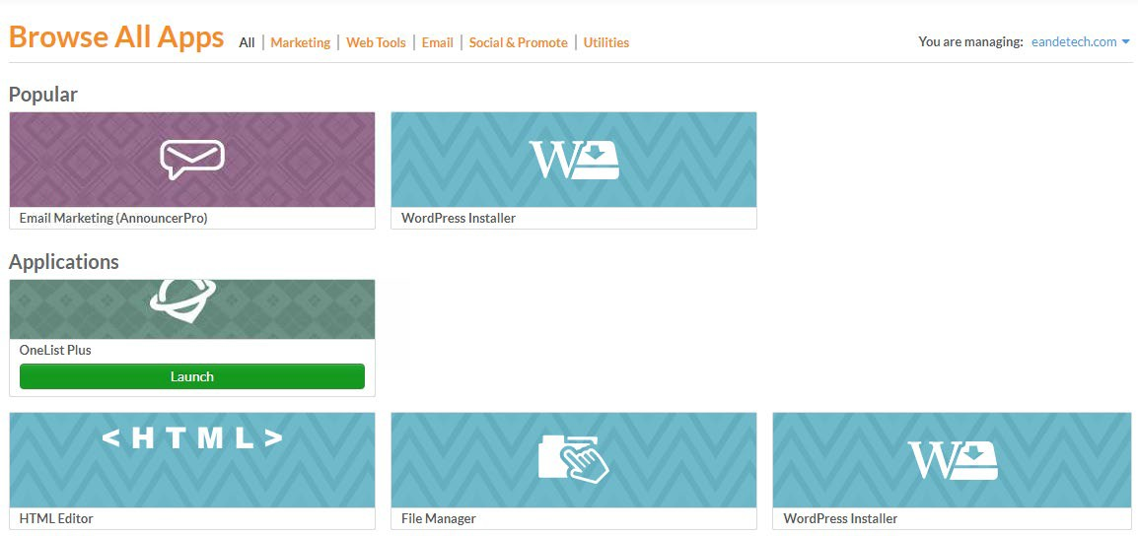

Account provisioning (creation) for OneList Plus will occur the first time users click the application. Once the account is provisioned, clicking the application opens a setup wizard. The wizard allows users to enter their business details. They can save and close, then enter additional information when they have it available.
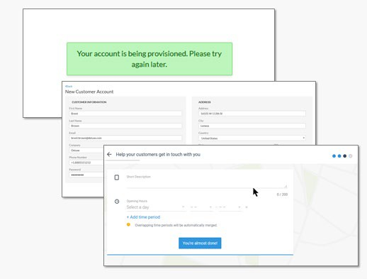

Set Up a New Profile
Select Profile from the top center navigation.

There are four sections:
- Basic Data – Name, location, hours, keywords, etc.

- Rich Data – Social media accounts, brands, language, services, etc.
- Photos & Video – Add logo, images, and videos.
- Suggestions – Once sync’d with the directories, other images or content might be found online. Users will see profile suggestions appear and can choose to add or decline those items from their listing data. These suggestions are meant to enhance their profile.
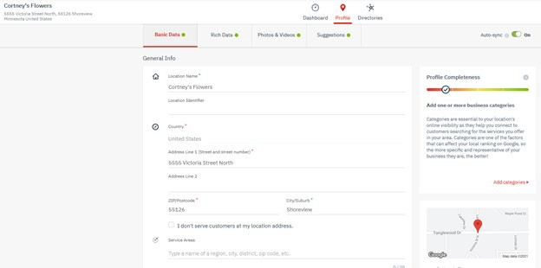

Go through each of the four tabs to submit the business’ information. To better understand what we are asking for, just click on the line item and a black box will appear with more detailed information about what is needed.
Make sure Auto-sync is always enabled.

OneList Plus Dashboard
- The dashboard gives users control over the directory listings profile.
- Users can see any tasks that need to be done.
- Users can click the icon to manage their profile information if it is incorrect or needs to be updated.
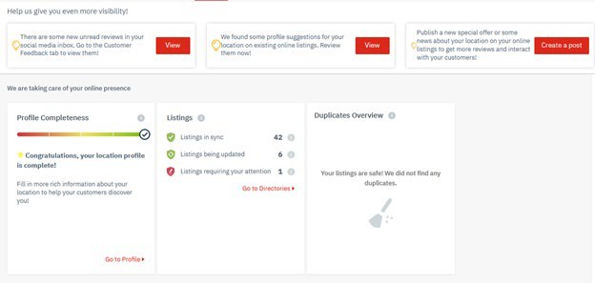

The Dashboard has three main sections:
- A top section for suggested enhancements
- A middle section with various tiles providing information
- The right side is a feed of all activities occurring in the account
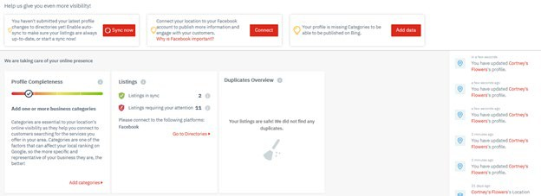

Tasks to be performed are displayed in a banner that will appear at the top of the dashboard. This could include completing the profile or connecting to the Google account.

On the Directories screen, users can see which directories their information is synced with and view directory listing by clicking on the icon.
If Google Business Profile or Facebook® are included in the plan chosen by the user, they will need to connect their accounts to sync their information via OneList Plus.
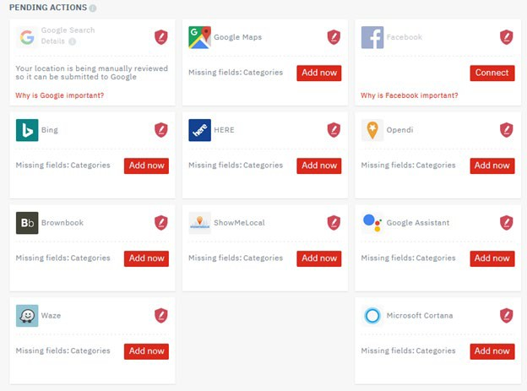

Connecting the Google Business Profile and Facebook® account will allow OneList Plus to update business information using the OneList Plus profile so that details are consistent in all directories.
Plus, once users connect Google Business Profile and Facebook®, they’ll be able to see insights including their profile impressions and clicks in their OneList Plus dashboard and reporting email.
Below is a view of the Directories tab with a synced business listing:

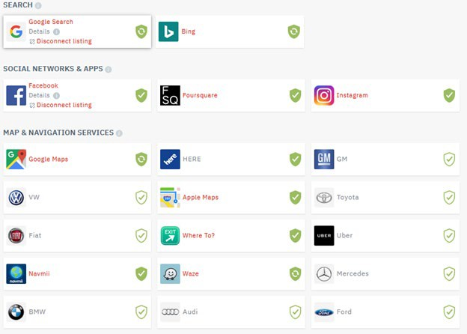

Sales Support

Probing Questions
When customers search for the products or services you offer in your area, does your business show up?
Submitting your business information to online directories helps your business get found where potential customers are searching for businesses like yours. First, it helps improve your rank on search engines like Google, by providing backlinks to your website and providing more citations for search engines to verify your business information.
Secondly, online directories often show up on the first page of search results. Customers also use directories to search for businesses directly. You need to ensure your business is visible and accurate!
With OneList Plus, you submit your information in once place, and it automatically creates directory listings in essential maps, business databases, GPS systems and more.

Is your business listed on Google Business Profile and in Google Maps?
Creating and verifying your Google Business Profile account is one of the best things you can do to help boost your local visibility! When potential customers search online or on Google Maps, you need to make sure your business can be found. It’s a critical first step because Google is the dominant search provider and has an overwhelming amount of search traffic, so you want to be setup where most customers start their searching.
Google Business Profile is included in our directory listing service, OneList Plus (applicable plans). You can connect your Google Business Profile account to make sure it shows consistent information with your other online listings, and you’ll get reporting on the impressions and clicks from your Google Business Profile.

How many directories are you listed in? How do you update them? How often?
We have directory listing packages that can include 40+ directories. However, the number of directories will vary depending on which package has been purchased. Being able to manage, sync and update your business information in a single dashboard means you don’t have to keep track of different profiles and log in credentials, because all your listings are managed right through the OneList Plus dashboard. Turning on “auto-sync” within the dashboard will ensure the directories are scanned daily and all information is maintained for accuracy.

Do you monitor your online listings?
Listings can change over time, overwritten by other search results and sometimes even by tampering. This can have a negative impact on your SEO. OneList Plus monitors, locks and protects your business info to ensure it stays accurate.

Selling Points
Get found online: Improve businesses visibility online. Having businesses listed in important online directories means more customers will find them. Plus, online directories can help improve SEO.
Save time: No more manual updates. OneList Plus updates all listings simultaneously. With auto- sync enabled, whenever users have an update, it gets published on all applicable directory listings.
Look credible and established: Submit a business description, logo and even images to multiple directories, so businesses looks established everywhere customers are looking.

Make sure the information is correct: Having incorrect business information online can hurt a business’ credibility in the eyes of customers, and search engines often will negatively score the business if information is deemed inaccurate or not up to date.
Monthly reporting: Review the dashboard monthly to get insights, reporting on the listings, as well as clicks and impressions if Google Business Profile or Facebook® is connected.

Competitive Information
How does OneList Plus compare to other directory listing services?

See Competitive Analysis

Objection Handlers

It’s too expensive/Don’t want to spend the money.

Can I ask how much you spend on other marketing, such as print or traditional? How many sales would it take to cover the cost of the monthly price?

98% of consumers used the internet to find a local business in the last year, with 21% searching every day (BrightLocal 2023). Increasing your online visibility means ultimately more money in your pocket. You gain customers through your door and top-of-mind presence. Plus, the more places you show, the more you’re outpacing the competition.

I already have a lot of listings.

Which directories are you listed in? (Can check for the business listings on Google Maps or use the directory scan.)

Do you keep track of your listings? Are you sure all your listings have the same details and are still up to date? You can use our simple online visibility tool to do a quick scan on your business to determine where you are listed and if your profile data is incorrect.

It’s important to monitor your listings because information can change, false data tends to multiply online and your data is open for editing. OneList Plus monitors and resubmits your listings so everything stays accurate.

With OneList Plus, you get:

- One-time, one-place submission across different directories
- Daily data matching, if the data is correctly listed on directories

Directory listings don’t need ongoing management.

If your listings or NAP (name, address, phone) information aren’t monitored, they will change over time. The average business listing changes every 6 days just looking at name, address or phone: a total of 61 times per year.

Listings may pull from outdated info found across the Internet, so it’s important to monitor your listings to keep them accurate. Using a synced submission like OneList Plus also means the exact same details and formatting are submitted to every directory, which will help search engines like Google rank your business and website. OneList Plus locks your listings if possible and scans your listings daily fixing any issues with your information.

Somebody is doing that for us already.

That’s great that you’re managing your online directories!

Can I ask, what is included in the management? What directories are included; and do they monitor and resubmit your listings ongoing? What information is submitted; does it include your logo, images, description and keywords?

How does it work if you need to update your information? Do you get any ongoing reporting? What does it cost?

No website/Waiting to launch our website.

One great thing about online directories is you can start immediately; you don’t need a domain or website in order to get your business listed and found online.

If you don’t have a website, then you definitely should sign up for listings now. Listings have a quick turnaround so your customers can find and get to know your business while you are building the website.

If you list your business now, it will show up in Google Maps and other directories. This is going to help customers find you and start building some online equity.

Once you have your website or domain ready, we can update your listing and it will get added to all of your directory listings.

We don’t need listings; we use Google AdWords or other search engine marketing tools.

That’s great that you’re using AdWords to market your business! Do you find it’s working?

Listings are still extremely important – even with AdWords, it’s still important to build your SEO so your business shows up in organic search results, as over 80% of people tend to click on organic links or directories. Also, a lot of people today are using ad blockers to hide ads in their browsers. If your business isn’t listed in directories or showing up on organic search results, you don’t get found by potential customers.

Plus, OneList Plus includes Google Maps, to help your business show up in Maps results which takes up almost a third of the real estate on a Google search result page.

Can you guarantee that I will show up higher in the rankings?

Unfortunately, no one can guarantee this to you. The best way for you to potentially appear at the top of the search rankings is to invest heavily in PPC (Pay Per Click). Getting higher rankings and exposure online is costly and doesn’t always ensure that you will get ROI. This OLP offering is an affordable service that will get you listed in the top online directories that you are not listed in today. Maintaining these listings with good quality data will help increase your overall SEO value. Think of it this way, imagine if you had 1 person on the corner telling people who you are and where they can find you. Now imagine if you had 25 or 40 people doing this in a consistent manner. This means that you get in front of more people in more places. This is the power of OneList Plus.

Frequently Asked Questions

General

What is OneList Plus?
OneList Plus is a tool that publishes profiles including business name, address, and phone number (NAP) and other information available to online directories. It enables businesses to automatically optimize their online presence for local searches.
OneList Plus lists and monitors your business across important online directories, including Facebook®, Google Business Profile, Google Maps, Bing Maps, Yelp and more.
With OneList Plus, you can manage your local listings in one place, so your business is listed consistently across many different platforms. This means you save time and hassle from having to manage multiple directories, and any updates to your business information only have to be made once.
Having your business listed in key; local directories help customers find your business in more places. Ensuring your listings have consistent information also helps your search engine ranking.

What are local directories?
A local directory listing is an online profile that contains your business name, address, phone number, and other details in an online directory or database of local businesses. Consumers use local directories to search for local businesses, either directly or through search engine results.
Some directories require you create a listing for your business, and some automatically create listings based on information found on the Internet or by indexing other directories. Search engines crawling your website validate your business by crawling directories to confirm your business information and domain.
To reach as many of your potential customers as possible it is essential to appear everywhere your customers and main search engines look for local business information. This means managing business profiles and listings across many different directory location platforms: social networks, maps services, business directories, recommendation platforms, GPS-systems and so on. Map directories and Data Aggregators push business information across a wide network of directories. From there, the business listing has the potential to reach hundreds of directories as business information is made available to directories across the web.

How does OneList Plus work?
OneList Plus has direct APIs or relationships with key online directories for instant or simplified listing submission. Your information is stored securely in our platform. Your company and location listings are automatically scanned daily and updated if required. Your listings are also protected against manipulation by third parties.
For certain directories or profiles that require accounts, OneList Plus requires you to provide authorization for access to your account to update the listing and ensure all your business details are consistent.

Why are local directories important for my business?
The more ways potential customers can find you online, the better. You can increase your digital presence by being listed in widely used online directories.
98% of consumers used the internet to find a local business in the last year, with 21% searching every day (BrightLocal 2023). To help your business be found by local customers, you should be listed with correct details on as many local directories as possible.
Local directories help your business get found in a number of ways: customers searching directly in directories are able to find your business; local directory results often show up on search engine result pages; and having consistent business information on key directories can improve your search engine ranking.

How do local directories improve my ranking on search engines like Google?
Having your business name, address and phone number consistent across online directories helps search engines determine the validity of your business. Inconsistent listings can confuse search engines and register as different businesses. The higher the number of consistent listings a search engine identifies of your business, the more likely it is the information is evaluated as accurate, up-to- date and important. Accordingly, the search engine concludes that your business is relevant to search queries in your area.
In addition, OneList Plus includes listing your business in the Google-owned directories Google Business Profile and Google Maps, as well as Bing in supported packages. This also has a positive effect on your search ranking.

I do not have a website. Do I get any benefits from local listings at all?
Yes! You don’t need a domain or website in order to get your business listed and found online.
If you list your business now, it will show up in Google Maps and other directories. This is going to help customers find you and start building some online equity.
Once you have your website or domain ready, you can update your listing and it will get added to all of your directory listings.

Listing and business information

Which information will I be able to include in the listings?
The basic information in your directory listings includes the following, and is subject to change:

- Business/company name (maximum 60 characters)
- Address (avoid abbreviations, e.g., include “Street” in place of “St.” When street numbers are followed by a letter, provide without space and in lower case letters, e.g. 5a.)

Phone number
- Business category
- Website/domain
- Email
- Fax
- Mobile phone
- Open hours
- Keywords
- Short description (200 characters)
- Long description (1000 characters)
- Logo (maximum 5MB, recommended 480 x 480 pixel resolution)
- Images (maximum 5MB per image, recommended 480 x 480 pixel resolution)
- Landscape image (maximum 5MB, recommended minimum 480 pixel resolution) Premium information can also be submitted, including:
- Video link (YouTube or Vimeo)
- Social media profile links
- Payment methods
- Brands
- Services

Can I use OneList Plus if I only have a PO Box address?’

No, you cannot use a PO Box. Most directories require a legitimate physical address used by the business to create business profiles.

What if I have a home-based business and want to hide my address?
Businesses without a public address that customers visit can have their physical addresses hidden by some but not all directories included on OneList Plus. In the case of hiding your address, your business information will not be submitted to directories that are unable to hide physical address information.

What kind of information should I include in the category field?
Your category is included in certain directories to narrow search results for people searching for your business type.
With OneList Plus, you may provide up to five (5) categories. Generally, it is advised to define the categories more broadly than specific. This will ensure your company will be easier to find by customers searching with generic terms.
Categories are directly linked to the directories. This means, even if each directory classifies the categories differently, the category will be automatically adjusted, and the visibility of your business is constantly secured.

What should I take into account when determining the keywords?
In the keywords section, you are limited to applying 10 keywords maximum that describe your business. The order in which you enter the keywords is important because the keywords will be prioritized accordingly.
The best keywords describe the products or services your business offers, as well as the “symptom” customers may be searching for. For example, an auto mechanic might include both “brake repair” and “squeaky brakes”.

What are the short and long descriptions used for?
Depending on the directory, either the short or long description is accepted or in some cases both formats are published.
Your description should be a short summary of your business offering and why customers should choose your business over your competitors. Your description will appear in your business listings so customers have quick visibility into your products, services or business model. It also helps your business appear credible and established.

What are images used for?
Certain directories accept and display images related to your business. This can include your logo and additional images.
Having images of your business location, products or portfolio can help add credibility to your business listing. Showing your location exterior can also help customers recognize your business.
Different image formats can be provided (squared or landscape) which will be automatically matched and fed into the directories depending on the required format. It is recommended to provide images with a minimum resolution of 480 pixels and a maximum size of 5MB.

What is the video used for?
Certain directories accept a video link as part of your business listing.
A video can help your business capture the attention of customers and prospects. Video will help your business look professional and established. There are many ways to create a video for your business; hiring a video agency, using an online tool to create a video, or simply recording and uploading a

video to Vimeo or YouTube. Your video might be an explainer-type video, a tour of your business, a demo or a compilation of images in a slideshow style format.

What are the social media profile links used for?
Certain directories accept and display your social media links as part of your business listing.
Prospective customers often turn to social media to learn more about your business or validate your business’ credibility. Including your social media links helps your business establish a complete online presence.

What kind of information can be displayed in the “payment methods” field?
Certain directories will display your available payment methods.
“Payment methods” is included to describe the modes of payment accepted by your business, such as cash, debit or credit. This is especially useful in certain industries such as restaurants, if only cash is accepted or if your establishment accepts credit cards.

What is the “languages” field used for?
Certain directories will display languages supported by your company.
“Languages” is used to indicate which languages are spoken at the respective location. This is particularly helpful for service providers such as doctors, or lawyers, for example.

What kind of information should I include in the “services” field?
Certain directories will display services offered by your company.
The “Services” field is used to list the services offered by your business. For example, a car mechanic might list changing tires, oil change and windshield repair. This helps customers confirm your business offers the products or services they are looking for.

Directory Specific Questions

What is Google Business Profile?
Google Business Profile is the account used to manage your online presence across Google, including Search and Maps. By verifying and editing your business information, you can both help customers find you and tell them the story of your business.
By integrating your company in the map service Google Maps, potential customers can find your business, learn of the opening hours and find directions to your business. Many local Google searches are performed via mobile. If your phone number is listed on Google Business Profile, the potential customer can contact you immediately with a single click.

Does OneList Plus create a new Google Business Profile page?
No, you will need to create a Google Business Profile through Google. It is also recommended you verify your Google Business Profile by following the instructions on your Google Business Profile account.

Does OneList Plus create a new Facebook® page for my business?
OneList Plus connects with your existing Facebook® Business Page or prompts you to create one.
If desired, an “unofficial” page can be connected to OneList Plus, claimed, and converted into an official company profile.
If a Facebook® page already exists, it will be detected and can be connected to OneList Plus. You will need to connect your Facebook® account through the Directories tab.

How does OneList Plus affect a Facebook® page?
Facebook® can be used as usual. Your company data and logo will be updated with the details listed in OneList Plus.

Listing submission

What if my business has multiple locations?
Each OneList Plus subscription is for one location. You can add multiple locations by adding multiple OneList Plus services. Your locations will be listed separately.

My business already has listings in several directories. How does this affect my OneList Plus submission?
Before creating a location page in any directory, OneList Plus scan directories for existing entries. In general, OneList Plus seeks to avoid creating duplicates.
If a listing already exists for a location, there are two possibilities. The first is that OneList Plus is able to directly claim the listing. If it can be claimed, your profile is then blocked for manipulation by third persons.
The second possibility is that the listing is 'claimed by others'. This may occur if you previously worked with another provider to optimize your online presence and the existing profiles are still claimed by this service provider or agency. In this case, the business owner is required to personally contact the directory and request a transfer of ownership so that OneList Plus is able to claim the profile.
If you are engaged in an ongoing contract with another provider of online presence management services, this contract must first be terminated. If the contract has already been terminated and there is only a short remaining term, the directory may be asked to transfer protection rights to OneList Plus ahead of time.
Should all of these approaches fail, OneList Plus will attempt to delete the listing and recreate it. The listing will be immediately protected against manipulation by third parties.

How long does it usually take to update or sync-check all data in the directories?
Usually, synchronization will only take a few minutes. When first creating a location, synchronization may take up to 12 hours or overnight with a few directories. In-car and navigation systems may have update cycles of up to 60-90 days.
Map directories and data aggregators publish available business information across a wide network of directories. These submissions are important for any business but the acceptance by directories is not trackable, we simply report on the submission to the map directory or data aggregator. From there the business listing has the potential to reach hundreds of directories as business information is made available to directories across the web.

How does OneList Plus ensure that the location data remain correct and will not be changed by unknown others?
The listings managed by OneList Plus are protected against manipulation by unknown third parties. If a listing is created/updated by OneList Plus, most directories block the listing so that no other user can make changes to the listing. Even in cases where a directory still allows users to suggest changes,
OneList Plus checks the listings every day and overwrites any information that does not match the information in OneList Plus. This is true for all directories except the car manufacturers and Factual.

Reporting

What reporting is included with OneList Plus?
You have access to reporting through your OneList Plus dashboard, which includes updates in the directories you are listed in, duplicate suppressions and if Google Business Profile and Facebook® are included in your plan and connected to your dashboard, impressions and clicks on your profiles.
While subscribed to OneList Plus, you can log into your dashboard to view or export insight reporting, summarizing the directories your business has been listed in and indicating any actions required to submit or improve your listings.

Is there a way to check to which extent the data listed in the directories is accurate and up-to- date?
OneList Plus provides a status check in order to be able to check the location data quality. The location data stored with OneList Plus is compared with the information published in the directories.

Contract/Cancellation

What happens when a location is closed down? What is the difference between the options cancel location and close location?
Close location: If you choose this option, the listing will be deleted from applicable directories. You should only select this option if the local business was closed down permanently. The location will be invoiced till the end of the contract period.
Cancel location: If you cancel a location, the listing and all location data exist in the directories and can be edited until the end of the contract period.

What happens to the location data after a location has been deleted or the contract expires?
If a location is deleted or your plan discontinued, your listings will no longer be locked or monitored and updated daily which means that third parties are able to modify the location data which means your information may become out of sync.

Full Directory List
Directories synced through OneList Plus are subject to change at any time without notice.

Top Directories

Directory | Description | Supports: Reviews | Supports: Reply’s | Support posting
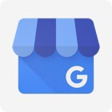  Google Business Profile | Google Business Profile(GBP) is a platform/tool provided by Google for businesses to manage their online presence across Google’s main Search and Maps functions. Google Business Profile has Connection to Google assistant.  Being the biggest online directory for local businesses with over 1 billion monthly visits, Google is the number one platform online. Businesses that verify their information with Google Business Profile are twice as likely to be considered reputable by consumers. | Yes | Yes | Yes
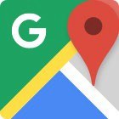  Google Maps | Google Maps is a map and direction platform developed by Google. It offers satellite imagery, street maps, 360° panoramic views of streets (Street View), real-time traffic conditions (Google Traffic), and route planning for traveling by foot, car, bicycle (in beta), or public transportation. Today's world of smartphones, mobile moments, and self- driving cars demands accurate location data more than ever. And no single search, maps, and apps provider is more important to brands' location marketing strategy than Google. Place labels are a feature of Google Maps that surfaces great content such as landmarks, businesses, and tourist attractions on our base map data. | Yes | Yes | Yes
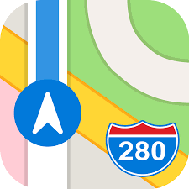  Apple Maps | Apple Maps is the default map system of iOS, macOS, and watchOS. It provides directions and estimated times of arrival for automobile, pedestrian, and public transportation navigation. Apple Maps is used by 23.3 million unique monthly users and is available worldwide. Apple Maps manages Business listings and is Connected to Apple’s virtual assistant Siri.
  Facebook® | Facebook is a social networking service publisher and offers the creation of company profiles for business presence. Facebook has more than 2.7 billion monthly active users and is available worldwide.  Companies can create Facebook® business pages displaying their information, offers and news as well as enable customer reviews. Connecting the OneList Plus with Facebook® strongly simplifies engagement with potential customers. | Yes | Yes | Yes
  Yelp | Yelp is a Listings and review platform, enabling users to search by category & location, find business details, provide reviews, and see businesses nearby. Over  30 Million Monthly Users/ 74 Million unique visitors per year and available | Yes

within United States & Canada. Businesses are listed on the platform, including detailed business information, photos, directions etc. To date Yelp has gathered more than 142 million reviews from a monthly average of 30 million
users.
  Bing Maps | With more than 20% of search market share in the United States (source: comScore) and rapidly increasing global traction, Bing is an essential part of the local ecosystem. More than 150M users search for local businesses and services on Bing every month. Bing also powers search results across the AOL portfolio of sites, including Huffington Post, Engadget, and TechCrunch.  Like Google, it allows businesses to add their listings for visibility on the Bing network.
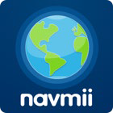  Navmii | Navmii is a voice-guided, turn-by-turn offline navigation app. It leverages crowd- sourced data from over 850,000 contributors to continually improve and optimize the navigation information it provides the global community it serves.  The Navmii application combines voice- guided navigation, live traffic information and local search for its more than 24 million drivers in over 150 countries.  Offline maps stored locally allows navigation without data connection. |  |  | Yes
  Opendi | Opendi is an international business directory with thousands of local business listings and reviews to help searchers find exactly what they're looking for. Powering critical information for 50 million listed businesses worldwide. Opendi's listings reach users in 29 countries across five continents. Opendi is a globally operating business directory with more than 9 million users worldwide. | Yes
  Where To? | The app Where To? offers a convenient way for users to search for local businesses by category. It works globally, has over 500 location types and even provides turn-by-turn directions to your chosen destination. Where To? doesn't just provide its users simple address information, but location data like photos, videos, descriptions, special offers, business hours, and more. | Yes | Yes | Yes
  HERE (maps) | HERE is a navigation and transport app. HERE combines highly accurate maps with cloud technology to power rich and real-time location experiences across over 1B connected devices. HERE's offline maps enable users to access critical location information—including 3D maps, live traffic, public transit, and venue maps—no matter where in the world they're searching from. HERE makes 2.7M+ map updates every day, drawing from more than 80,000 different data sources and 196 countries. HERE's map data also powers the in-dash navigation system HERE We Go, used by 4 out of 5 drivers in North America and Europe.

  Waze | Waze is a community-based navigation application for advanced GPS navigation, particularly for road driving. Users share real-time traffic information as well as travel times and fuel prices along the way to help other users have a more enjoyable driving experience. As a community-based traffic and navigation app, Waze was created as a social navigation tool for private cars. There are currently 100 million users worldwide.
  Foursquare | With a community of over 60  million registered users and more than 55 million monthly active users worldwide, Foursquare is the leading location-based social network. Foursquare's users can not only access details about local businesses, but provide other users recommendations or tips, publicly check-in to locations, and more. Its hyper-active userbase has left more than 70M recommendations and has made over 7B check-ins to local businesses. Users write reviews and get rewards like coupons for checking in at new places. | Yes
  Brownbook.net | Brownbook.net is a global business listings database, listing information for over 35M businesses across over 200 countries worldwide. Where users can add and edit business information freely. With its search function Brownbook provides business information, map locations as well as information about other businesses nearby. Verified listings are marked with a “claimed“ badge. | Yes |  | Yes
  USCity.net | USCity.net is one of the first and oldest directories first available on the web. USCity.net helps its 450K+ active monthly users find information about local business information, map location and similar businesses nearby. |  |  | Yes
  Yalwa | With users in more than 65 countries and over 18 million business entries worldwide, Yalwa is a listing site that allows their users to find business information about local businesses, leave ratings and comments for other community members to read. | Yes

  acompio.com | Acompio is operating worldwide in more than 20 countries providing business information and enabling review functions for users. The directory includes more than 6 million businesses from 1300 branches. | Yes
  pages24.com | Operating mostly in Europe (Ricercare Imprese in Italy, Busqueda Local in Spain), but also in America, Pages24 provides business information, reviews, directions, and businesses nearby. |  |  | Yes
  iglobal | iglobal is an online business directory with presence in more than 60 countries around the globe. It provides its more than 5 million worldwide users per month with business information, reviews, and ratings.
  tupalo | Tupalo provides its more than 3 million monthly visitors in 9 countries (mainly Europe) with information about local businesses, enabling search, discover and share features. Users can create their own favorite-places list and leave comments about their experience.
  Hotfrog | Hotfrog is a local listings platform for users to get business information, directions and reviews. Present in 38 countries around the globe and having listings of more than 120 million businesses, around 1.6 million users use the listing site every month |  |  | Yes
  uber | Uber is a peer-to-peer ridesharing, food delivery, and transportation network company. Uber matches drivers with their passengers and to bring them to their  desired destination.
  Cylex | Cylex is a global online business directory in over 30 countries and more than 1 million unique users daily. It provides business contact information, opening hours, directions as well as reviews. Part of the Cylex Network are other business directories like find-open in the English- speaking countries and finde-offen/  trouver-ouvert in the European countries.
  Instagram | Instagram is a social networking platform that allows sharing photos and videos.  Users can share images publicly, privately or to pre-approved followers. It provides users with several photo editing options and filters. Reach: - 2.5 billion yearly visits. |  | Yes
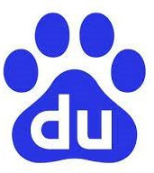  Baidu Intl | Baidu International is a search directory. Reach: 120 billion daily average location search requests on Baidu Maps Countries available: Worldwide, excluding China (Hong Kong, Taiwan, Macau)
  Yandex | Yandex is a search engine with listings function, displaying business information, mapping location with directions. Reach:  2.9 Billion visits per month

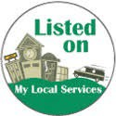  mylocalservices.com | MyLocalServices is an online business directory in the US and UK, where users can review and add business listings or visit the business support forum. | Yes | Yes | Yes
  Citysquares | The CitySquares directory provides small, independent businesses an opportunity to reach a qualified, local consumer audience through a profile on its website. Users can simply search for businesses nearby using the search bar. | Yes |  | Yes
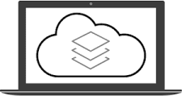  Localstack | Localstack is a US directory giving recommendations and providing search results based on social media activity. A social media score is calculated based on trending analysis for million of businesses across the US. |  |  | Yes
  Bell | Canadian Business Directory, part of Bell, Canada’s largest media company. 42,000 categories of industrial products and Services, 600,000 Canadian companies  and over 1,7 Million International listings.
  WAND | WAND is a business-to-business directory listing companies for 172 countries in 70,000 different product and service categories. The site allows users to search by various regions or internationally, by products and services, and company name. In addition, users can search for products and services by various categories such as agriculture and forestry, electrical and electronics, and  packaging.
  Manta | Operating in the English-speaking countries, Manta provides its 20 million monthly visitors with business information, map location and businesses nearby. The platform offers additional education/advise  for small businesses.
  Factual | Factual is a location data company today become a part of Foursquare. Its focus is to help marketers and their organizations to better, target and measure to build and execute digital advertising strategies, understand audiences.
  ShowmeLocal | Showmelocal is an online directory operating in the US, Canada, UK and Australia. With over 19 million businesses, 750,000 claimed listings and more than 335,000 user review, showmelocal  provides their users with business information, coupons, deals and jobs. | Yes |  | Yes
  Judy´s Book | Judy’s Book is a US based local directory, where users get additional advice, deals and discounts for businesses. 4.5 million reviews from over 450,000 US members help users find the right place. To date Judy’s book has over 11 million listings online. | Yes | Yes | Yes
  n49.com / n49.ca | Operating in the US, Canada, and UK, n49 is an online directory and networking site allowing users to upload business information, media and reviews via the ReviewUs link, where users are redirected and can rate individual locations. | Yes |  | Yes
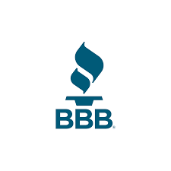  Better Business Bureau | The BBB rating is based on information BBB is able to obtain about the business, including complaints received from the public. BBB seeks and uses information directly from businesses and from public data sources.  BBB assigns ratings from A+ (highest) to F (lowest).
  ChamberofCommerce | ChamberofCommerce.com is an online business directory offering small business solutions. Users can search by type of business or individual business name; alternatively, they can manually browse  the directory by selecting city and category.
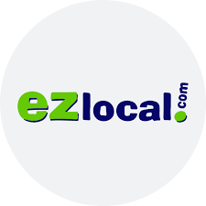  EZlocal | Ezlocal is a leader in digital presence management helping thousands of business locations manage their content across Internet directories, online maps, social networks and search engines. They offer a search directory as well. | Yes |  | Yes
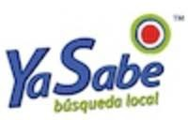  YaSabe | YaSabe is a Hispanic oriented community guide for users to find businesses and other local information. The YaSabe network includes commonly known US- Hispanic newspapers and online news portals (Al Dia, La Voz, Mundo Hispanico, El Tiempo Latino, Palm Beach Post, AhoraSi, Univision, Chron) as well as the local Hispanic platform latinos.us,  attracting millions of Hispanic and US readers daily. | Yes |  | Yes
  Houston Chronicle | Part of YaSabe. YaSabe is a leading digital media and technology company helping employers and advertisers reach  Hispanics in the US.
  Univision | Part of YaSabe. YaSabe is a leading digital media and technology company  helping employers and advertisers reach Hispanics in the US.
La Voz | Part of YaSabe. YaSabe is a leading digital media and technology company helping employers and advertisers reach Hispanics in the US.
  Palm Beach Post | Part of YaSabe. The Palm Beach Post is an American daily newspaper serving Palm Beach County in South Florida, and the Treasure Coast area. YaSabe is a leading digital media and technology  company helping employers and advertisers reach Hispanics in the US.
  Mundo Hispanico  (The Atlanta Journal Constitution) | Part of YaSabe. YaSabe is a leading digital media and technology company helping employers and advertisers reach Hispanics in the US.
  Statesman (The  Austin American Statesman) | Part of YaSabe. YaSabe is a leading digital media and technology company helping employers and advertisers reach Hispanics in the US.

